Q1

LOGIN PAGE

<!DOCTYPE html>

<html>

    <head><h1><center>login form</center></h1></head>

        <body>

            <form action="empinfo.html">

            <center>

            <table  border="0">

                <tr>

                    <td rowspan="2"><img src="https://icon2.cleanpng.com/20180816/jae/kisspng-computer-icons-login-user-system-administrator-ima-editing-mafsyah-template-5b75843a7b1045.0356392015344282185041.jpg" width="200" height="200"></td>

                    <td colspan="2">Login id:<input type="text" pattern="[EMP]{3.3}"maxlength="6" name="LOGINID" placeholder="EMPXXX" pattern="[EMP]{3}.{3}"  required></td>

                </tr>

                <tr>

                    <td colspan="2">password<input type="password"maxlength="16"  placeholder="password" name="PASSWORD" pattern=".{7,16}" required ></td>

                </tr>

                <tr align="center">

                    <td colspan="3"><center><input type="submit" name="submit" value="login" ></center></td>

                </tr>

                <tr>

                    <td colspan="3"><input type="checkbox"name="rembchek" value="remb"><b>Remember me&nbsp;&nbsp;&nbsp;&nbsp;&nbsp;||&nbsp;&nbsp;&nbsp;&nbsp;&nbsp;<a href="signup.html">sign up</a>&nbsp;&nbsp;&nbsp;&nbsp;||&nbsp;&nbsp;&nbsp;&nbsp;&nbsp;<a href="forgotten_password.html">forgotten password?</a></b></td>

                </tr>

            </table>

            </center>

        </form>

        </body>

</html>

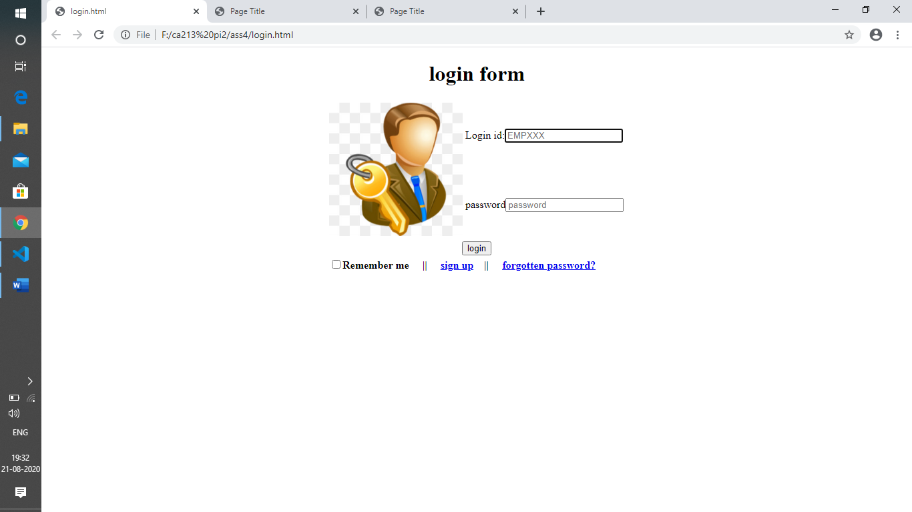

Q2

EMPLOYEE PAGE

<!DOCTYPE html>

<html>

<head>

    <meta charset='utf-8'>

    <meta http-equiv='X-UA-Compatible' content="IE=edge">

    <title>Page Title</title>

    <meta name='viewport' content='width=device-width, initial-scale=1'>

    <link rel='stylesheet' type='text/css' media='screen' href='main.css'>

    <script src='main.js'></script>

</head>

<body>

    <font size="9"><center>Enter Employee Detail.</center> </font>

        <form>

        <table border="0" >

            <tr>

                <td><b>Name:</b></td>

                <td><input type="text" name="name" required placeholder="jjhon"pattern="{MRS,MS,MR,A-Z}" ></td>

            </tr>

            <tr>

                <td><b>User ID:</b></td>

                <td><input type="text" name="LOGINID" placeholder="USER ID" pattern="[EMP]{3}.{3}" required ></td>

            </tr>

        </tr>

        <td><b>Gender:</b>

        </td>

        <td><label><input type="radio" name="gen">male</label>

            <label><input type="radio" name="gen">female</td></label>

    </tr>

            <tr>

              <td> <b>Birthday:</b> </td>

                <td><input type="month" name="bdaymonth" min="1990-01" max="2000-12"> </td>

            </tr>

            <tr>

                <td><b>Email:</b> </td>

                <td><input type="email" name="email"></td>

            </tr>

            <tr>

                <td><b>Joinging month and year:</b> </td>

                <td><input type="month" name="joingmonth" min="2000-01" max="2018-06"></td>

            </tr>

            <tr>

                <td><b>Employee designation:</b></td>

                <td>       <input type="text" placeholder="Enter your designation "></input>

                </td>

<tr>

<td><b>Employee Skills:</b> </td>

<td><input type="text" placeholder="Enter your Skills"></td>

</tr><br><br>

</table>

<table >

<tr align="center">

    <td colspan="3"><input type="submit" name="submit" value="submit" formaction="Success.html">

<form novalidate>

    <input type="submit" name="submit" value="login"  formaction="Login.html" ></td>

    </form></td></tr>

</table>

   </form>

</body>

</html>

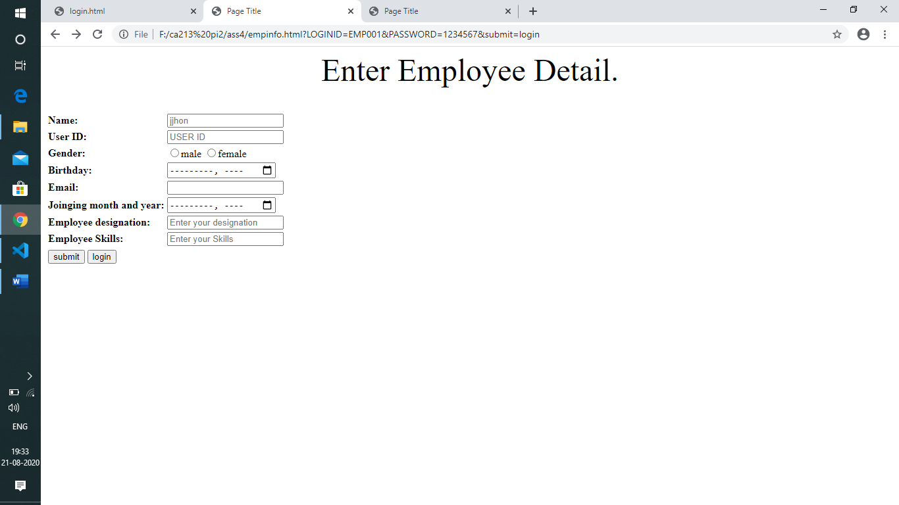

Q3

SUCCESS PAGE

<!DOCTYPE html>

<html>

<head>

    <meta charset='utf-8'>

    <meta http-equiv='X-UA-Compatible' content='IE=edge'>

    <title>Page Title</title>

    <meta name='viewport' content='width=device-width, initial-scale=1'>

    <link rel='stylesheet' type='text/css' media='screen' href='main.css'>

    <script src='main.js'></script>

</head>

<body background="https://cdn1.vectorstock.com/i/1000x1000/69/85/simple-of-a-palm-tree-vector-9976985.jpg">

    <table align="center">

        <tr ><td>

       <font size="100" color="red"> Your Data is Submitted Successfully </font></td></tr></table>

</body>

</html>

